Practice Test Paper-1:

1) HTML Stands for

2) What is current version of HTML

3) IDE Stands for

4) Which IDE Is Suitable IDE to develop web applications

5) CSS Stans for

6) Why CSS? Write minimum 3 points

7) What is the Current version of CSS

8) What is Bootstrap?

9) What is Angular?

10) What is React?

11)Explain MEAN Stack?

12) Explain MERN Stack?

13) Explain MEVN Stack?

14) Write Features of HTML5.X?

15) Explain Semantic Elements in HTML5 with Diagram?

16) How to play audio in HTML5

17)How to play Video in HTML5

18)What is attribute write few points?

Ans:

19) Write basic Structure of Web Pages

Ans:

20) What DOCTYPE?

Ans:

21) Write DOCTYPE for HTML5.X

22) What is METADATA?

Ans:

23) Write the Differences Between Container TAGS and Non-Container TAGS?

Ans:

24) How to develop static web pages

25)What is the Extension for HTML Pages

26) What are the types of tags?

27) What are container tags?

Ans:

28) What are non-container Tags>

Ans:

29) What is HTML Element?

Ans:

30) What is the extension of CSS files

31) What is the extension of JavaScript files

32) How to implement Forms Validations

33) How to execute HTML, CSS and JavaScript

34) Write the Examples for Browsers?

Ans:

35) Write the Examples for IDE’S?

Ans:

36) Who given VSCode?

37) Which IDE Recommended to develop web applications

38) How to give line break

39) How to draw Horizontal line in webpages

40)Are comments executed by browsers? (yes/no)

41)Write the Syntax for HTML Comments

PRACTICE PAPER-2

1) Write the Tags to create Headings in HTML

Ans:

2) How to apply external CSS?

Ans:

3) What is padding in CSS?

4) What are Block Level Elements?

Ans:

5) Are Headings Block Level Elements? (yes/no)

6) write the html code to develop below application with headings

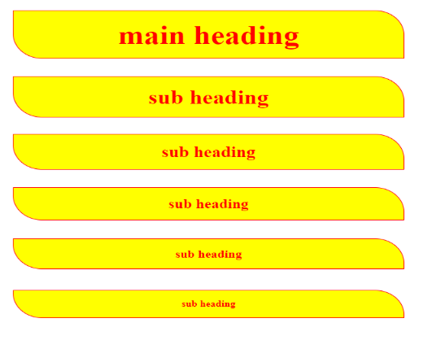

PRACTICE PAPER-3:

1) which tag is used to create the Paragraphs _

2) Are Paragraphs Block Level Elements? (yes/no)

3) how to convert block to inline

4) how to convert inline to block

5) complete the below application with paragraphs

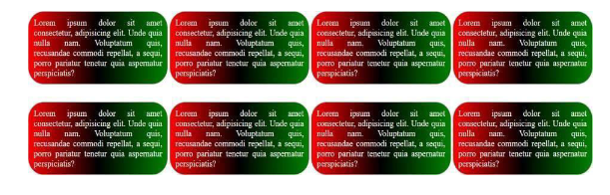

PRACTICE PAPER-4:

1) How to apply internal styles to the web pages

2) write the Differences between external CSS and Internal CSS?

3) how to create Divisions in HTML

4) Explain Selectors in CSS?

5) Class selector should start with

6) ID Selector should start with

7) Differences Between Class selector and ID Selector?

8) How to create universal selector

9) Write the code for below application

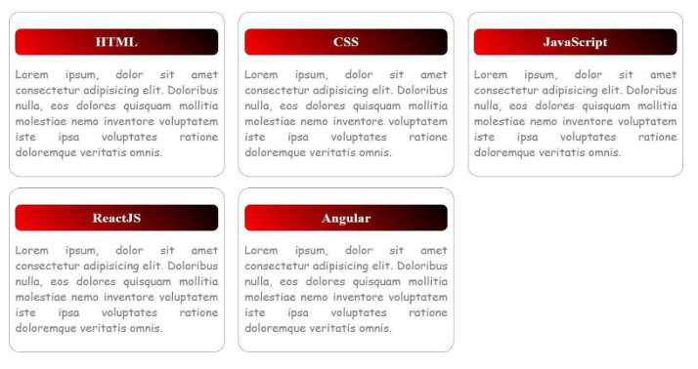

PRACTICE PAPER-5:

1) How to Create Button and Write Basic Example

Ans:

2) Explain <span> tag in HTML?

Ans:

3) Are Button Span and img tags are inline (yes/no)

4) How to write inline CSS

5) In How Many ways we can apply CSS?

Ans:

6) Explain CSS Specificity?

Ans:

7) How to display images in HTML _

8) Is <img> tag paired tag? _

9) Write <img> tag attributes

Ans:

10) Explain hover in CSS?

Ans:

11) write the code for below application

PRACTICE PAPER-6:

1) How to create Hyper Links in HTML?

Ans:

2) Write Attributes of Anchor Tag?

Ans:

3) implement the below application with anchor tag

Flipkart -> https://www.flipkart.com/

Amazon -> https://www.amazon.in/

AJIO -> https://www.ajio.com/

Myntra -> https://www.myntra.com/

Load above web sites in new tab

4) implement the below application with anchor tag

PRACTICE PAPER-7:

1. Design the Below Application with fieldset and legend

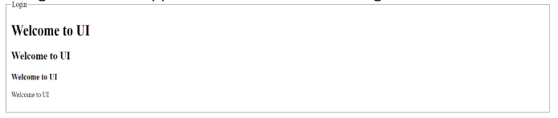

PRACTICE PAPER-8:

1) which tag used to create tables

2) write the tags to create tables with diagram

Ans

3) write table attributes with explanation

Ans

4) write the code for below diagram in practice paper and execute in laptop

5) write the code for below diagram in practice paper and execute in laptop

6) write the code for below diagram in practice paper and execute in laptop

7) write the code for below diagram in practice paper and execute in laptop

8) write the code for below diagram in practice paper and execute in laptop

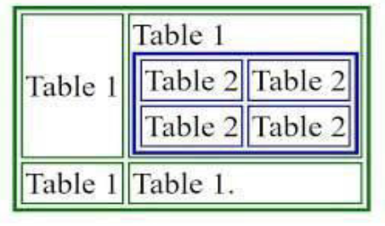

9) write the code for below diagram in practice paper and execute in laptop

10) write the code for below diagram in practice paper and execute in laptop

11) write few points related to font-awesome

12) cart symbol

13) trash symbol

14) edit symbol

15) rupee symbol

16) dollar symbol

17) user profile

18) how to use font-awesome

19) CDN Stands for

20) is Font Awesome CSS library?

PRACTICE PAPER-8:

1) Types of Lists in HTML?

Ans:

Practice Paper

2) Write the Syntax for Ordered List?

Ans:

3) Write the Attributes of Ordered List?

Ans:

4) Write the Syntax for Unordered List?

Ans:

5) Write the Unordered List Attributes?

Ans:

6) Write the Syntax for Definition List

Ans:

7) <dt></dt> stands for

8) <dd></dd> stands for

9) <li></li> stands for

10) <dl></dl> stands for

11) Write the code for below application and execute in laptop

12) Write the code for below application and execute in laptop

13) Write the code for below application and execute in laptop

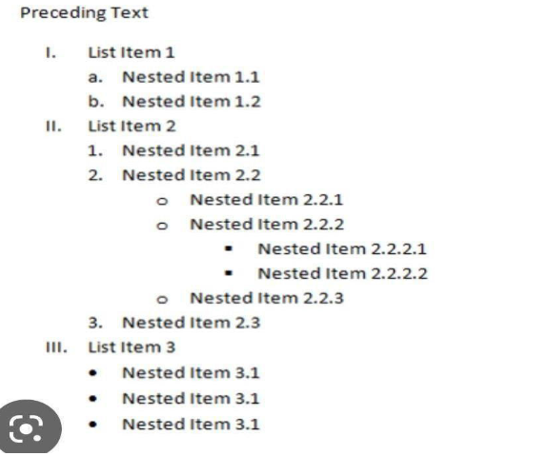

14) Write the code for below application and execute in laptop

PRACTICE PAPER-9:

1) How to create Forms in HTML

2) Write form attributes

3) Why placeholder attribute in <input></input> tag

4) How to create dropdown in Forms write basic example

5) How to create address field in HTML Forms

6) Single selection controls called as

7) Multi selection controls called as

8) implement the below form with text field

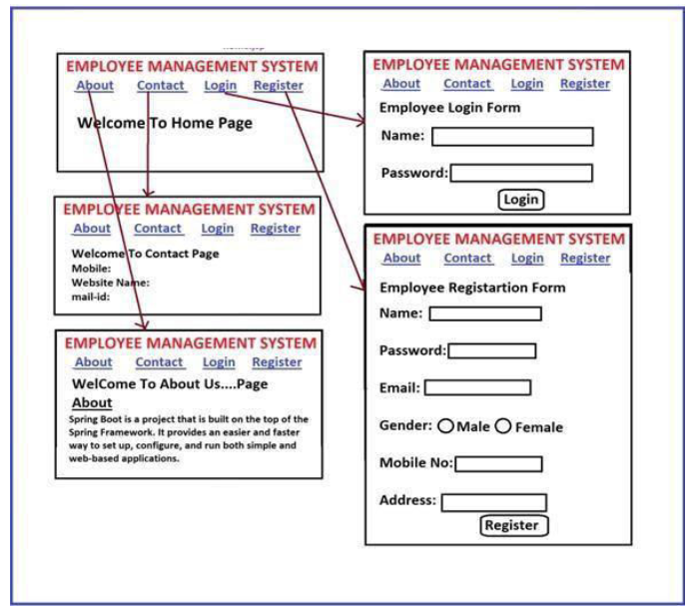

9) implement the below form

10) implement the below form

11) Write HTML code to get following text box?



12) Write HTML Code for following output

13) Write code for following output

14) Write Code for following output

15) Write code for following output

16) Write HTML code to for following Output



17) Write HTML Code for following output



18) Write HTML code for following output

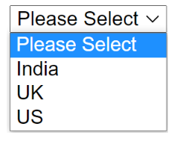

19) implement the below form

PRACTICE PAPER-10:  
1) Explain Positions in CSS?

2) What are the Differences Between Absolute and Relative Positions?

3) Implement The Below Application Absolute Position

4) Implement the Below Application with CSS Relative Position

5) What is Z-Index in CSS?

6) Which one is the default position in CSS

7) How to display Element in center of webpage

Ans:

8) What is border-box in CSS?